IP2 Trip Length Distribution Analysis By User Class

User Class 1 – Taxi
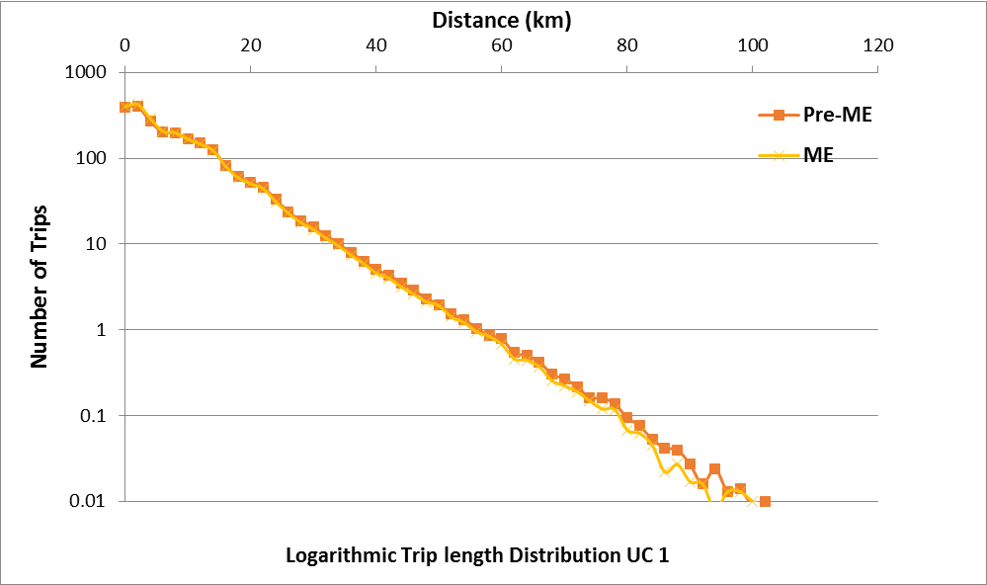

User Class 2 – Car Employers Business
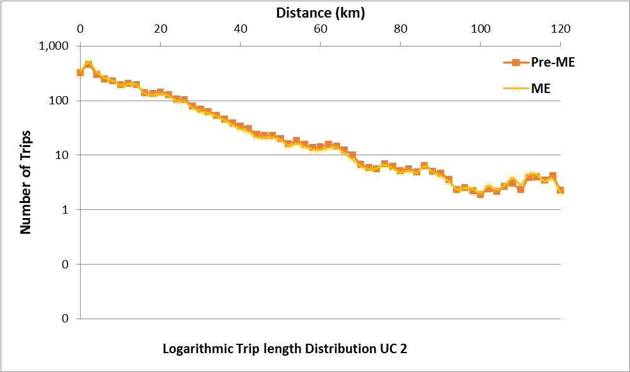

User Class 3 – Car Commute
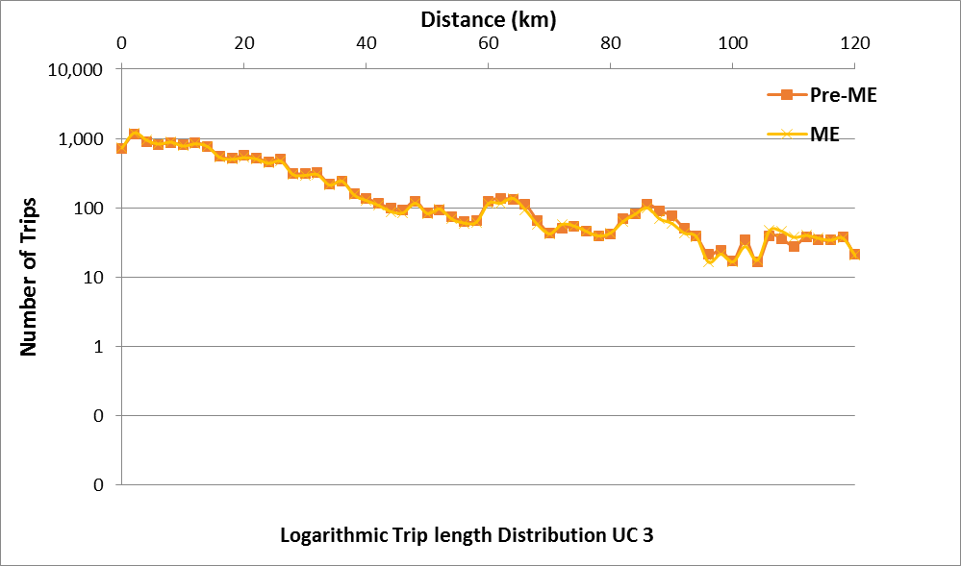

User Class 4 – Car Education
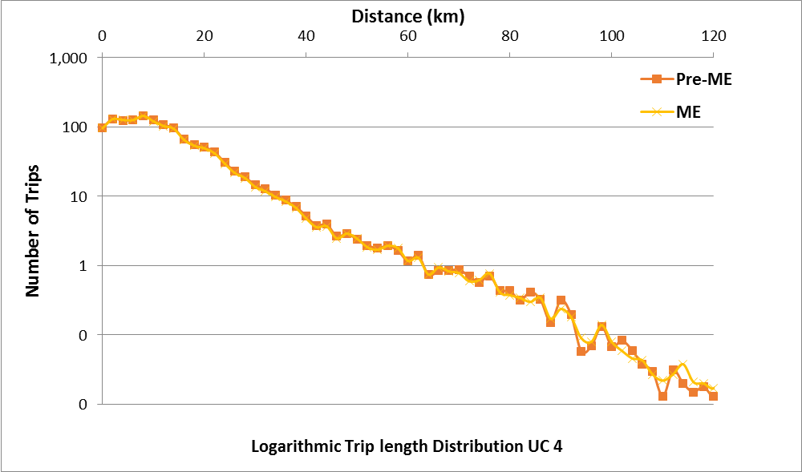
User Class 5 – Car Other
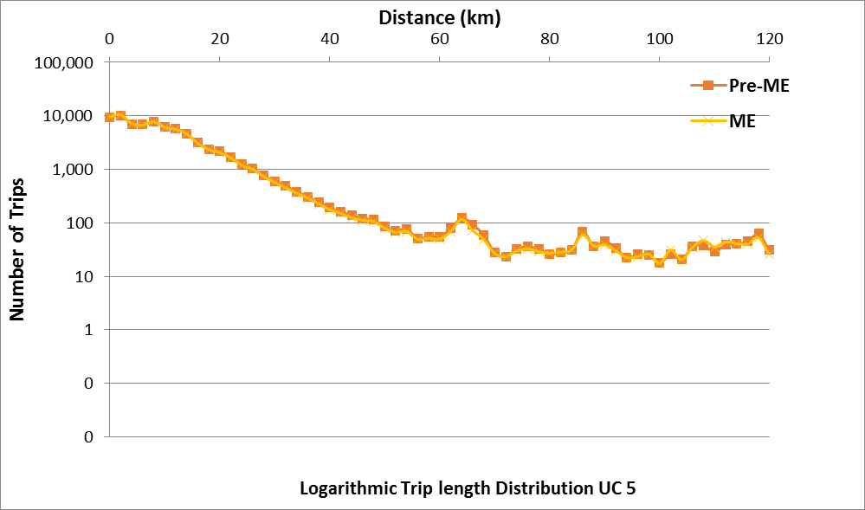

User Class 6 – Light Goods Vehicles
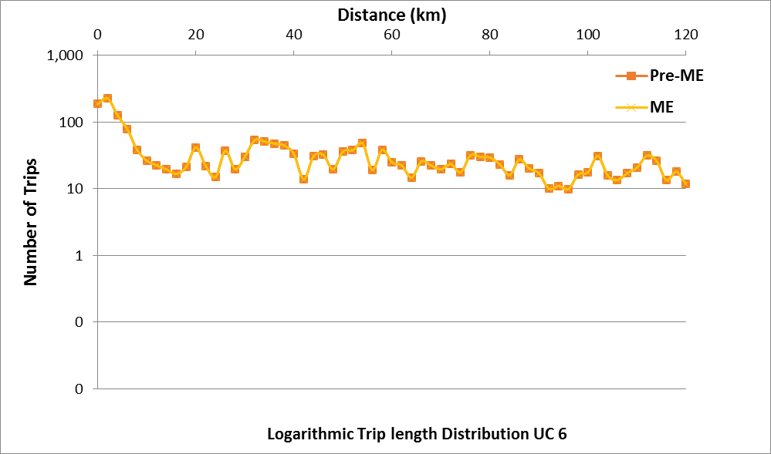
User Class 7 – OGV1
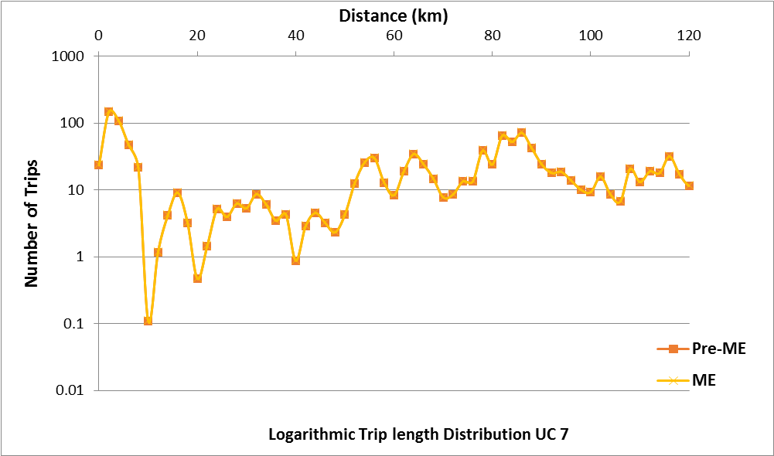

User Class 8 – OGV2
